https://78bbm3rv7ks4b6i8j3cuklc1-wpengine.netdna-ssl.com/wp-content/uploads/2015/08/1-var-stats.pdf
#32: Answer ( c )

The Choices below are for 4 data sets. In the choices, ‘w’ is a constant.
There are FIVE values in each data set.
Each Choice has the same MEAN. Which has the greatest Standard Deviation?

- W – 2 W – 1 W W + 1 W + 2
- W – 2 W – 2 W W + 2 W + 2
- W – 3 W – 1 W W + 1 W + 3
- W – 3 W W W W + 3

The TI-84 Calculator can do some amazing things.
In 6th and 7th grade you learned about the MEAN and the M.A.D (Mean Absolute Deviation).
The Standard Deviation is the Square of the Difference in the MAD.

The M.A.D. for each of the data sets is: SUM MAD
- | -2 | | -1 | 0 1 2 6 6/5 1.2
- | -2 | | -2 | 0 2 2 8 8/5 1.6
- | -3 | | -1 | 0 1 3 8 8/5 1.6
- | - 3 | 0 0 0 3 6 6/5 1.2

https://www.scribbr.com/statistics/standard-deviation/

The “Denominator is ‘N-1’ (or for this problem: 5 - 1 = 4) to make an adjustment for data.
Standard Deviation uses the SUM of the Square of the Difference: (BY HAND)
Sum Sum / (n-1) Std Dev
- 4 1 0 1 4 10 10 / 4 = 2.5 $\sqrt{2.5}$ ~ 1.58
- 4 4 0 4 4 16 16 / 4 = 4.0 $\sqrt{4}$ 2.00
- 9 1 0 1 9 20 20 / 4 = 5.0 $\sqrt{5}$ ~ 2.23
- 9 0 0 0 9 18 18 / 4 = 4.5 $\sqrt{4.5}$ ~ 2.12

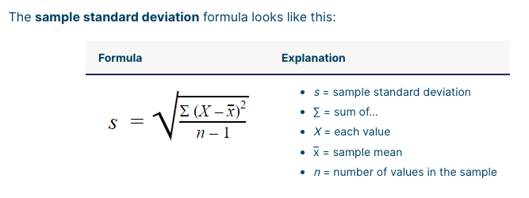

Just for the example, If we use W = 10,

Then the Data Values would be: SUM Mean
- 8 9 10 11 12 50 10
- 8 8 10 12 12 50 10
- 7 9 10 11 13 50 10
- 7 10 10 10 13 50 10

On the TI-84:
[STAT]
{1: Edit} <enter>
Enter data in an L# (Column)
[STAT] {CALC}
{1: Var Stats}
It uses the (L1) List as the default.
Or use [2nd] key and the enter the number 1 thru 6 for another L# group of data.

Select the {Calculate} option
$$\overline{X}=MEAN=10 for all the Samples$$

$$Standard Deviation:$$
- L1 Sx ~ 1.58
- L2 Sx ~ 2
- L3 Sx ~ 2.23
- L4 Sx ~ 2.12

