- Interpret a linear graph  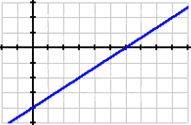 | - What is the slope of the line?  - What is the Equation of the line in slope intercept form?  - What is the slope of a line that is perpendicular to the line

- Complete the (X, Y) Rotation Table for the various rotations for a parallelogram ABCD.
Point | 90⁰ |  | 180⁰ |  | 270⁰
A: (-3, 5)

- Coin problem. John has 30 coins consisting of Quarters and Dimes.
The value of the coins is $4.20. How many of each coin does he have?

- Translation: Figure ABCD is translated 3 units left and 2 units down.
What are the locations of point B’ ?
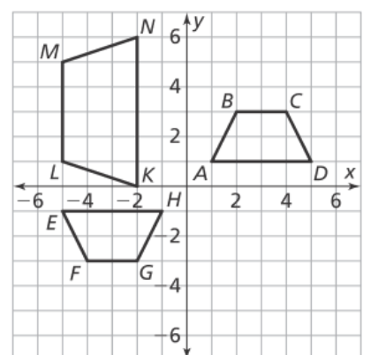

- Draw the Reflection figure (B) across the y-axis
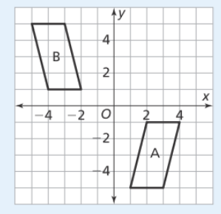

- What is the slope and y-intercept of a line in Standard Form of:
5x + 7y = 70

- What is the value of variable (a)? 3(2a - 4) + 5(2a - 4) = 16

- Simplify the Radical: $\sqrt{60}\sqrt{90}$ (May leave in reduced Radical Form)

- Approximate the $\sqrt{84} as a mixed number.$

- Simplify: $\frac{a^{6}b^{3}c^{-2}}{a^{3}bc^{-2}3^{-2}}$
- A boat goes up-stream and it takes him 4 hours. The return trip takes 2 hours.
The speed of the river is 2 miles per hour. What was the average speed of the boat?

- Business Terms:
Abraham opens a Lemonade stand. He makes 5 pitchers of Lemonade at a cost of $4 per pitcher. Each pitcher can hold 10 glasses of Lemonade.
He sells his lemonade for 80 cents per glass. He sells 35 glasses.
- What was his Revenue?
- What was his Expense?
- What was his Income?
- Express .0000458293232 in Scientific Notation
14)
X | Y | Which Equation fits the Data?
1 | 13 | - 2x + y = 24  - 5x – y = 35  - 3x + y = 16  - None
2 | 10
3 | 7
4 | 4

15) The equation of a Parallel Line to a line with Points: (0, 1) and (1, 4)
A) y = 2x B) y = 2x – 3 C) y = 3x - 2 D) None

- Express: .34$\overline{8}$ as a fraction (in simplest terms).

